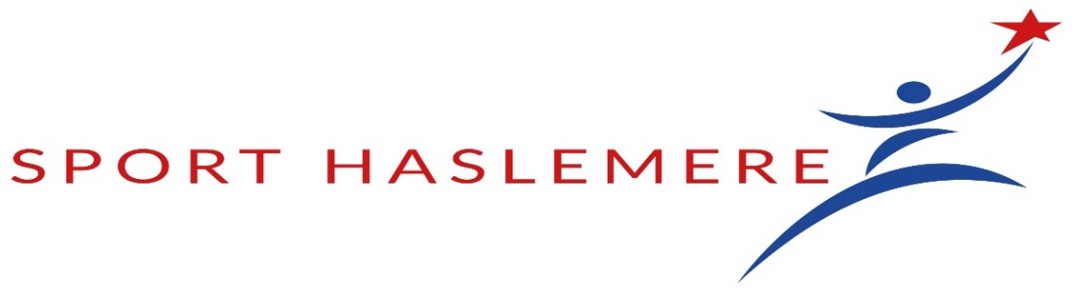

CATEGORIES OF AWARD AND NOMINATION CRITERIA

- Achievements must be between 1st September 2023 and 31st August 2024
- Nominees must meet at least two of the criteria

SPORTS PERSONALITY OF THE YEAR

An individual aged 19 + at the time of achievement who has made significant progress in the field of sport; has had a significant impact on sport in the local area and been an inspiration to others and who has exceeded expectations in their sporting performance or made a significant difference to a team.

JUNIOR SPORTS PERSONALITY OF THE YEAR

An individual who is under 18 at the time of achievement and who has made significant progress in the field of sport; has had a significant impact on sport in the local area and has been an inspiration to others and who has exceeded expectations in their sporting performance or made a significant difference to a team,

SPORTS CLUB OF THE YEAR

A formally constituted Sports Club that has a proven track record of working with schools, local authorities and other community organisations; has evidence of commitment to effective recruitment, recognition and training of volunteers,coaches and players,actively encourages participation from under-represented groups(e.g people with a disability) and has implemented new ideas and demonstrated innovation.

SPORTS COACH OF THE YEAR

A coach who has made a positive impact by increasing participation levels and/or inspiring & encouraging others to progress in their sport; has evidence of personal development in the last 24 months and has a professional approach with excellent dedication.

YOUNG COACH OF THE YEAR

A coach who is under 25 at the time of their achievement and who has a minimum of Level 1 NGB Coaching award in the sport they are being nominated for; has increased participation levels by inspiring and encouraging others to progress in their sport;has evidence of personal development in the last 24 months and has a professional approach with excellent dedication.

SPORTS TEAM OF THE YEAR

A sports team aged 19+ at time of achievement that have achieved success and competed at a consistently high level throughout the year; who have demonstrated fair play and a good sporting attitude throughout the year and have shown significant improvement from previous years.

JUNIOR SPORTS TEAM OF THE YEAR

A sports team that is under 18 at the time of achievement and that have achieved success and competed at a consistently high level throughout the year; who have demonstrated fair play and a good sporting attitude throughout the year and have shown a significant improvement from previous years.

SPORT AWARD FOR THE DISABLED

An individual who has made a significant impact on disability sport and has been an inspiration to others; has devoted continuous time and resources to the development of disability sport; has overcome barriers to excel in sport and has been a role model/mentor for other disabled people.

HASLEMERE SPORT INITIATIVE

An individual who has contributed significantly to sport over a minimum of 5 years; has demonstrated continued enthusiasm and devoted time and resources to enable others to take part and has increased participation and enjoyment of sport in their community

SPECIAL SERVICES TO SPORT AWARD

An individual who has contributed significantly to sport over a minimum of 5 years; has demonstrated continued enthusiasm and devoted time and resources to enable others to take part (please include the range and number of people helped and any personal sacrifices made);increased participation and enjoyment of sport and made a positive impact in their local community.

YOUNG VOLUNTEER OF THE YEAR

A coach, official, administrator or general helper who is under 18 at the time of achievement and who has demonstrated enthusiasm and commitment to a sport or club; has made tremendous impact on a club or organisation through volunteering and has shown a commitment to personal development, team working and supporting the development of other volunteers.

.

SPORTING IMPACT & INNOVATION IN SCHOOLS

A school that has created a new activity/approach to engage the diverse needs of young people; has actively engaged with all young people to identify and deliver appealing activities and appropriate environments and has used alternative activities to embrace new partners in the delivery of out of school hours learning e.g parents, community partners or providers

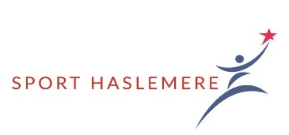
Haslemere Sports Awards 2024

Nomination Form

The purpose of these awards is to acknowledge outstanding performance or standards of service within the local sporting environment and to applaud and embrace the thriving local sporting community. Nominations can be made by any bona fide individual, club or organisation affiliated to Sport Haslemere and applications are welcome for more than one of the categories.

An adjudicating panel will assess the nominations and the awards will be presented at the Haslemere Sports Awards on Wednesday 9th October 2024 in the Haslemere Hall at 7.30pm.
Award winners will receive an appropriate trophy (to hold for one year) as well as a perpetual momento.

Nominee
Full name(s) (in capitals) of nominated Individual, Team or Club
(All names for team nominations)

Award Category

(Please complete further details overleaf)

Nominated by
Surname Forenames

Email address and telephone number

Organisation (if applicable) | Position/Connection
I confirm that to the best of my knowledge, the details given in support of this nomination are correct and that the Nominee is/would be happy to receive this award.

Signed Date

Position in club

Reasons for nominating Individual/Team/Club

Please keep to under 350 words if possible.
Use another form if you are nominating more than one person.

The completed form must be returned as soon as possible and in any event not later than 9th September 2024 to:

Adrian Blyth
Adrian@adrianblyth.com

Or post to: Adrian Blyth,Headley Road,Grayshott,GU26 6LB

Tel: 07831 295373

